Visitor
(Behavioural)

The Visitor design pattern is a behavioral pattern that allows you to add new operations to a group of related classes without modifying their structures. It is particularly useful when you have a stable set of classes but need to perform various operations on them, making it easy to extend functionality without altering the existing codebase.
Example of Decorator Method Design Pattern
For example, think of a Shopping cart where we can add different type of items (Elements). When we click on checkout button, it calculates the total amount to be paid. Now we can have the calculation logic in item classes or we can move out this logic to another class using visitor pattern.
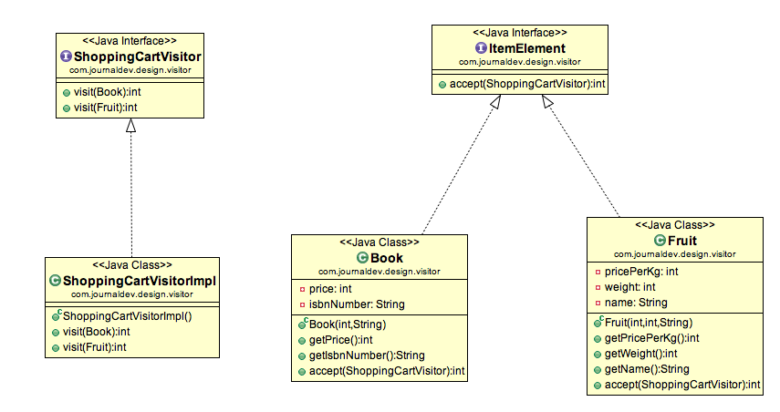

1. Element interface
public interface ItemElement {

public int accept(ShoppingCartVisitor visitor);
}

2. Concrete Elements
public class Book implements ItemElement {

private int price;
private String isbnNumber;

public Book(int cost, String isbn){
this.price=cost;
this.isbnNumber=isbn;
}
public int getPrice() {
return price;
}
public String getIsbnNumber() {
return isbnNumber;
}
@Override
public int accept(ShoppingCartVisitor visitor) {
return visitor.visit(this);
}
}
public class Fruit implements ItemElement {

private int pricePerKg;
private int weight;
private String name;

public Fruit(int priceKg, int wt, String nm){
this.pricePerKg=priceKg;
this.weight=wt;
this.name = nm;
}
public int getPricePerKg() {
return pricePerKg;
}
public int getWeight() {
return weight;
}
public String getName(){
return this.name;
}
@Override
public int accept(ShoppingCartVisitor visitor) {
return visitor.visit(this);
}
}

3. Visitor interface
public interface ShoppingCartVisitor {
int visit(Book book);
int visit(Fruit fruit);
}

4. Concrete Visitors
public class ShoppingCartVisitorImpl implements ShoppingCartVisitor {

@Override
public int visit(Book book) {
int cost=0;
//apply 5$ discount if book price is greater than 50
if (book.getPrice() > 50){
cost = book.getPrice()-5;
} else cost = book.getPrice();
System.out.println(
"Book ISBN::"+book.getIsbnNumber() + " cost ="+cost);
return cost;
}

@Override
public int visit(Fruit fruit) {
int cost = fruit.getPricePerKg()*fruit.getWeight();
System.out.println(fruit.getName() + " cost = "+cost);
return cost;
}

}

Demo
public class ShoppingCartClient {

public static void main(String[] args) {
ItemElement[] items =
new ItemElement[]{
new Book(20, "1234"),
new Book(100, "5678"),
new Fruit(10, 2, "Banana"),
new Fruit(5, 5, "Apple")
};

int total = calculatePrice(items);
System.out.println("Total Cost = "+total);
}

private static int calculatePrice(ItemElement[] items) {
ShoppingCartVisitor visitor = new ShoppingCartVisitorImpl();
int sum=0;
for(ItemElement item : items){
sum = sum + item.accept(visitor);
}
return sum;
}

}

Output:
Book ISBN::1234 cost =20
Book ISBN::5678 cost =95
Banana cost = 20
Apple cost = 25
Total Cost = 160

Visitor Pattern Benefits
- The benefit of this pattern is that if the logic of operation changes, then we need to make change only in the visitor implementation rather than doing it in all the item classes. Another benefit is that adding a new item to the system is easy, it will require change only in visitor interface and implementation and existing item classes will not be affected.
Visitor Pattern Limitations
- The drawback of visitor pattern is that we should know the return type of visit() methods at the time of designing otherwise we will have to change the interface and all of its implementations. Another drawback is that if there are too many implementations of visitor interface, it makes it hard to extend. Thats all for visitor design pattern, let me know if I have missed anything. Please share it with others also if you liked it.

Resources:
https://www.geeksforgeeks.org/visitor-design-pattern/
https://www.digitalocean.com/community/tutorials/visitor-design-pattern-java

